The purpose of this lab is to (1) get more familiar with MDK compiler and (2) learn how to define variables and arrays in assembly and how they are organized in memory.

**AREA main, CODE, READONLY**

**EXPORT __main ; make __main visible to linker**

**ENTRY**

**__main PROC**

**ldr r0,=Scores ; r0= the begining address of Scores**

**ldr r0,=Miles ; r0= the begining address of Miles**

**ldr r0,=Speed ; r0= the begining address of Speed**

**ldr r0,=Half_Word_Array ; r0= the begining address of Half_Word_Array**

**ldr r0,=MSG1 ; r0= the begining address of MSG1**

**ldr r0,=Searchfor ; r0= the begining address of Searchfor**

**ldr r0,=Volt ; r0= the begining address of Volt**

**ldr r0,=Byte_Array ; r0= the begining address of Byte_Array**

**ldr r0,=Zero_Array ; r0= the begining address of Zero_Array**

**ldr r0,=Ones_Array ; r0= the begining address of Ones_Array**

**stop B stop ; dead loop & program hangs here**

**ENDP**

**ALIGN**

**AREA myData, DATA, READWRITE**

**; Define an array of two words called Scores - initialize it with 0XAABBCCDD and 370**

**; Define a word variable called Miles - initialize it with 0xBBBBBBBB**

**; Define a half word variable called Speed - initialize it with 0xAABB**

**; Define an array of two half words called Half_Word_Array - initialize it with 0x00FF and 20000**

**; Define a message (an array of characters) called MSG1 - the message is "Enter 4 Digit PIN?" add Null delimiter at the end**

**; Define a character variable (a byte variable that stores a character) called Searchfor - Initialize it with @**

**; Define a byte variable called Volt - Initialize it with 120**

**; Define an array of bytes called Byte_Array - Initialize it with -1,0xA2, and 2_11110000**

**; Store zeros in 8 bytes - call this array Zero_Array**

**; Store 0xFF in 10 byets - call this Ones_Array**

**END**

1. Define the variables and arrays for the comments given in the data area
2. Run the code given in the code area to find the beginning address of the variables and array

**Things to turn in as your Lab1 Report:**

A. Your Code **[20 marks]**

B. Snapshot of the window. Justify if the memory is different from the one below. **[5 marks]**

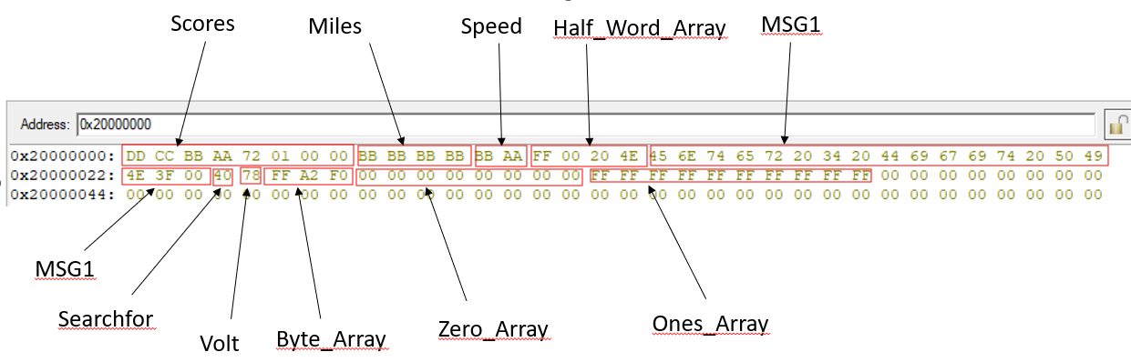

C. The beginning addresses of each variable and array. **[5 marks]**

D. Is Big Endian or Little Endian used to store the data? **[5 marks]**